

**FLY AWAY PLUS**

**DETAIL DESIGN DOCUMENT**

**Class Design**

**Project Code: FAP**

**Document Code: FAP_Class Design_v1.2_EN**

**Hanoi, 13 June 2015**

**SIGNATURE PAGE**

AUTHOR: Dương Thanh Hải 13/06/2015

Team member

REVIEWERS: Hoàng Nghĩa Đức 13/06/2015

Project Manager

APPROVAL: Nguyễn Văn Sang 16/06/2015

Supervisor

**RECORD OF CHANGE**

*A - Added M - Modified D – Deleted

|  |  |  |  |  |  |
| --- | --- | --- | --- | --- | --- |
| **Effective Date** | **Changed Item** | **A,M,D** | **Change Description** | **Reason for Change** | **Rev. Number** |
| 13/Jun/2015 | Create Screen Design | A |  |  | 1.0 |
| 14/Jun/2015 | Update Screen Design | M |  |  | 1.1 |
| 21/Aug/2015 | Update Screen Design | A,M |  |  | 1.2 |

Table of Contents

**SIGNATURE PAGE** 2

**RECORD OF CHANGE** 3

**1.** **INTRODUCTION** 5

1.1. Purpose 5

1.2. Definitions, Acronyms and Abbreviations 5

1.3. Overview 5

**2.** **Screen flow** 6

# **INTRODUCTION**

## Purpose

To ensure consistency and simplicity in detailed design across all displays within a product interface, as well as across other products used by the same users. Definitions, acronyms, abbreviations, references and overview of FAP website.

## Definitions, Acronyms and Abbreviations

|  |  |  |
| --- | --- | --- |
| Abbreviations | Description | Comment |
| FAP | Fly Away Plus | Social network of travelling |
| Q&A | Question and answer |  |

## Overview

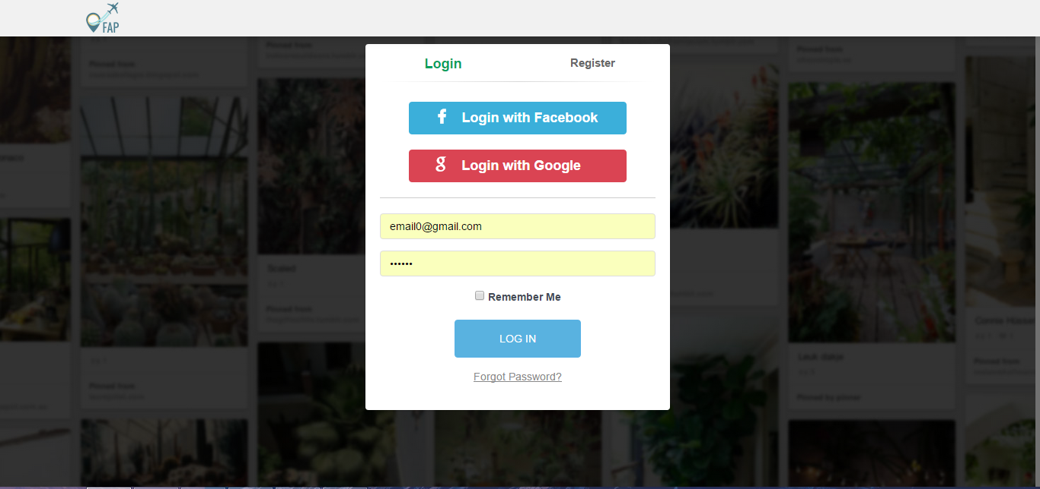

# **Screen flow**

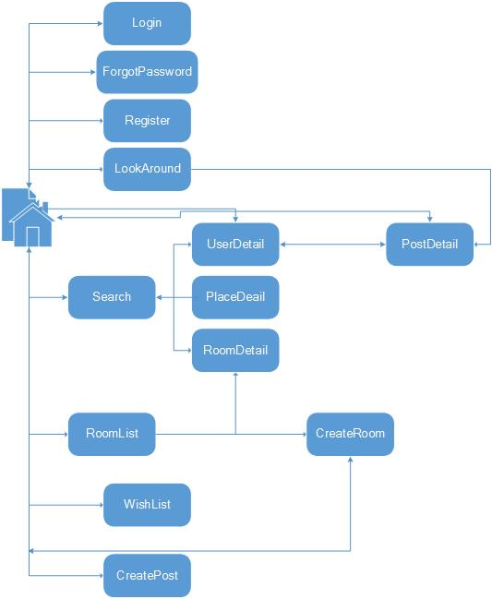

#### Search

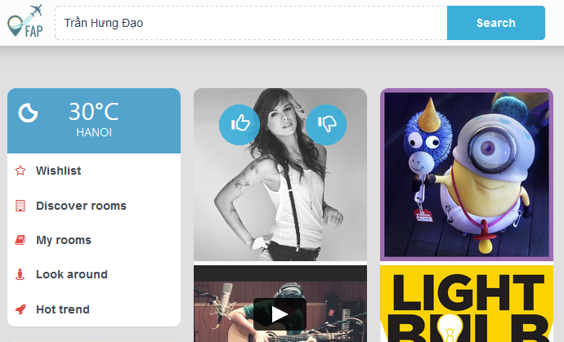

Figure 1: Search place screen design

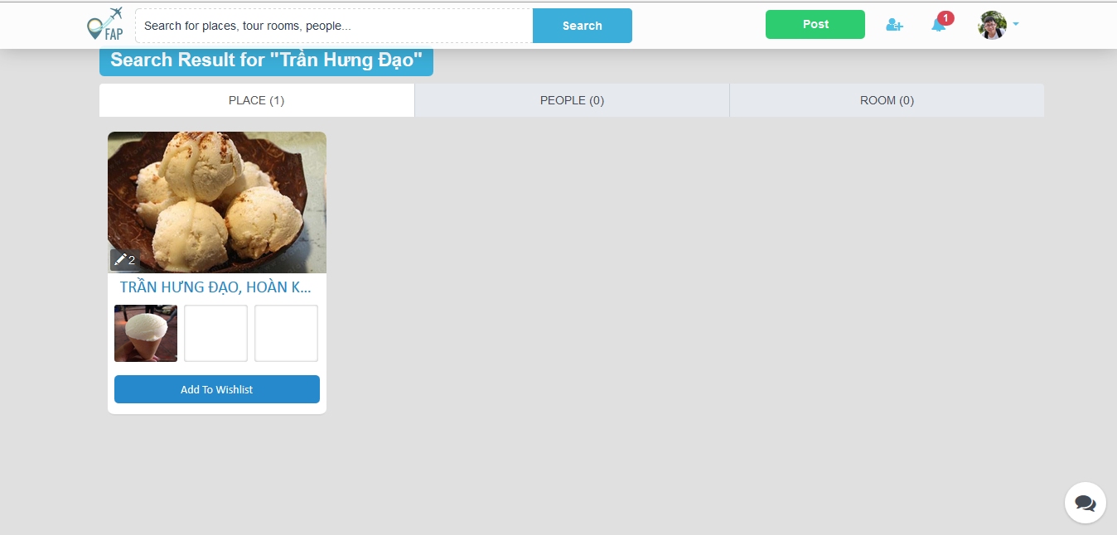

Figure 2: Search place result screen design

|  |  |  |  |  |  |  |  |
| --- | --- | --- | --- | --- | --- | --- | --- |
| No | Field name | Field name in Vietnamese | Type | Require | Mandatory | Max-Length | Description |
| 1 | Search result for | Kết quả tìm kiếm | Text |  | Y |  | Display text |
| 2 | Place tab | Tab địa điểm | Tab | Click | Y |  | Display result as place |
| 3 | People tab | Tab người dùng | Tab | Click | Y |  | Display result as people |
| 4 | Room tab | Tab phòng | Tab | Click | Y |  | Display result as room |
| 5 | List place | Danh sách địa điểm | List |  | Y |  | Display list of place as result |

##### Search User

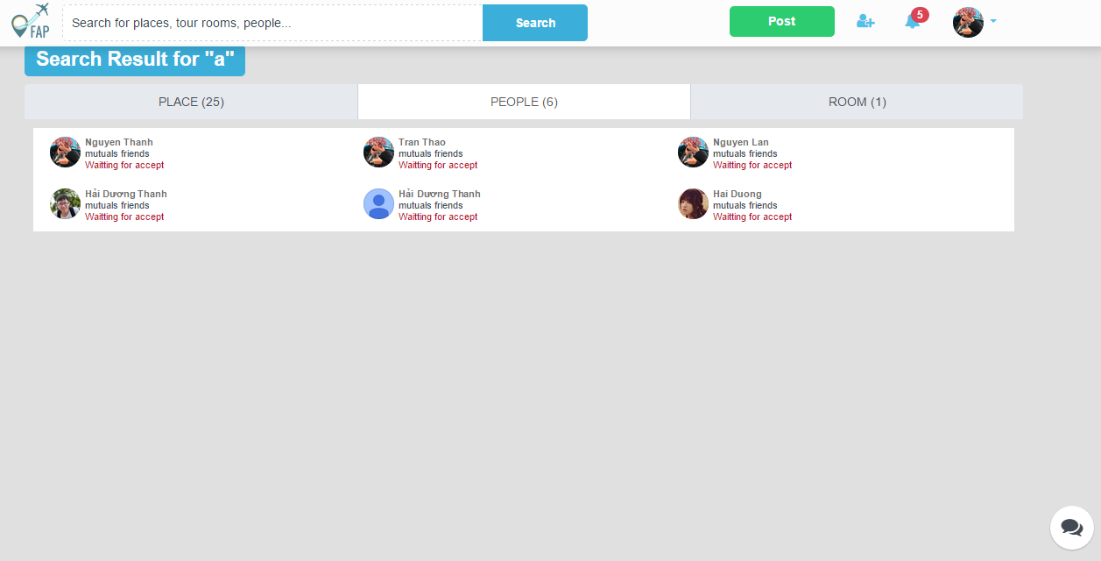

Figure 29: Search user screen design

|  |  |  |  |  |  |  |  |
| --- | --- | --- | --- | --- | --- | --- | --- |
| No | Field name | Field name in Vietnamese | Type | Require | Mandatory | Max-Length | Description |
| 1 | Search result for | Kết quả tìm kiếm | Text |  | Y |  | Display text |
| 2 | Place tab | Tab địa điểm | Tab | Click | Y |  | Display result as place |
| 3 | People tab | Tab người dùng | Tab | Click | Y |  | Display result as people |
| 4 | Room tab | Tab phòng | Tab | Click | Y |  | Display result as room |
| 5 | List user | Danh sách người dùng | List |  | Y |  | Display list of user as result |

##### Search Room

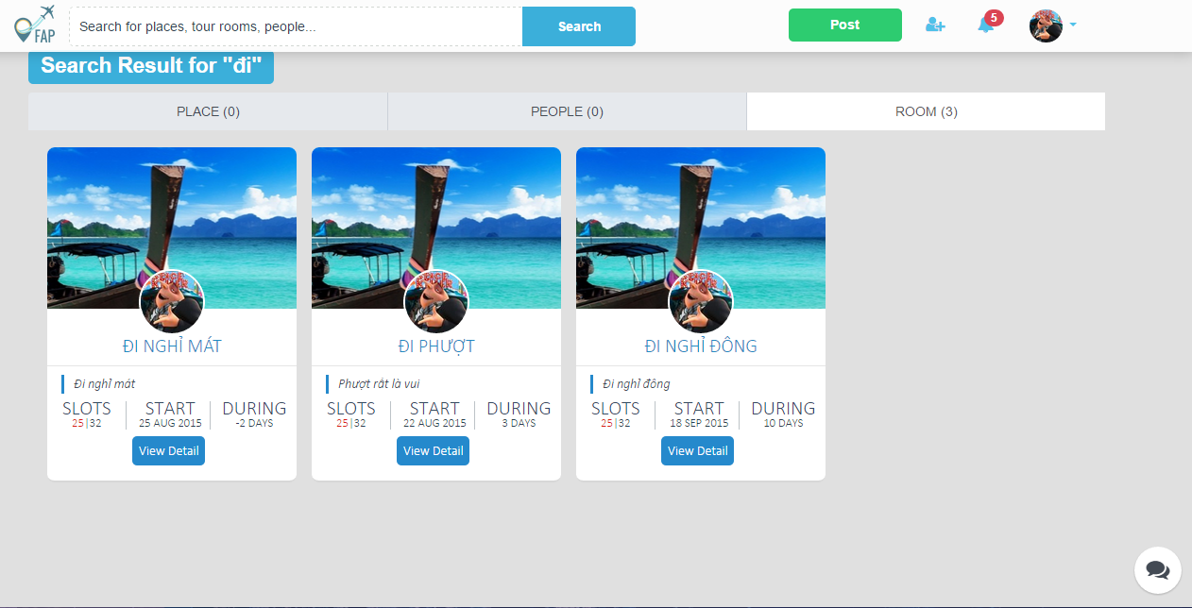

Figure 31: Search room screen design

|  |  |  |  |  |  |  |  |
| --- | --- | --- | --- | --- | --- | --- | --- |
| No | Field name | Field name in Vietnamese | Type | Require | Mandatory | Max-Length | Description |
| 1 | SearchResult | Kết quả tìm kiếm | Text |  | Y |  | Display text |
| 2 | PlaceTab | Tab địa điểm | Tab | Click | Y |  | Display result as place |
| 3 | People tab | Tab người dùng | Tab | Click | Y |  | Display result as people |
| 4 | RoomTab | Tab phòng | Tab | Click | Y |  | Display result as room |
| 5 | ListRoom | Danh sách phòng | List |  | Y |  | Display list of room as result |

#### Help Center

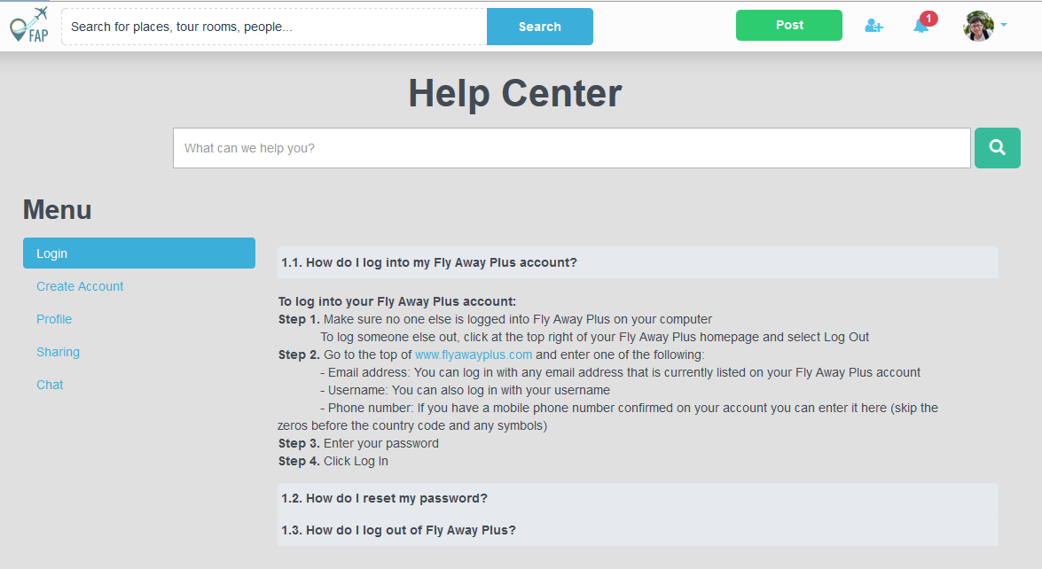

Figure 34: Help Center screen design

|  |  |  |  |  |  |  |  |
| --- | --- | --- | --- | --- | --- | --- | --- |
| No | Field name | Field name in Vietnamese | Type | Require | Mandatory | Max-Length | Description |
| 1 | HelpCenter | Trung tâm hỗ trợ | Label | Label |  |  | Label display “Help Center” |
| 2 | SearchText | Từ khóa tìm kiếm | Text | Text |  |  | Text for searching question |
| 3 | SearchBtn | Nút tìm kiếm | Button | Click |  |  | User click on search button for searching result |
| 4 | ListQuestion | Danh sách câu hỏi và câu trả lời | List | List | Y |  | List of question and answer |

#### Suggest

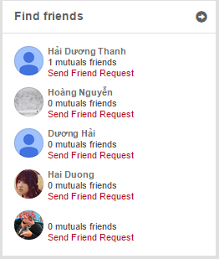

Figure 37: Suggest Friend screen design

|  |  |  |  |  |  |  |  |
| --- | --- | --- | --- | --- | --- | --- | --- |
| No | Field name | Field name in Vietnamese | Type | Require | Mandatory | Max-Length | Description |
| 1 | ListSugguestedFriends | Danh sách bạn gợi ý | List |  | Y |  | Display list of sugguested friends |

#### Suggest Place

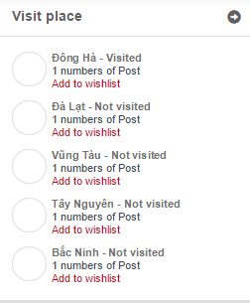

Figure 39: Suggest place screen design

|  |  |  |  |  |  |  |  |
| --- | --- | --- | --- | --- | --- | --- | --- |
| No | Field name | Field name in Vietnamese | Type | Require | Mandatory | Max-Length | Description |
| 1 | ListSugguestedPlaces | Danh sách các địa điểm gợi ý | List |  | Y |  | Display list of sugguested places |

#### Personal Page

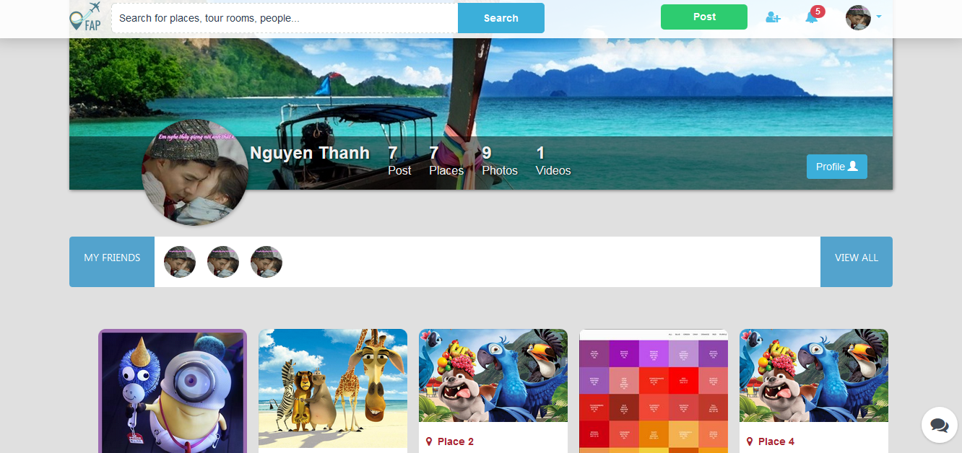

Figure 42: User Personal Page screen design

|  |  |  |  |  |  |  |  |
| --- | --- | --- | --- | --- | --- | --- | --- |
| No | Field name | Field name in Vietnamese | Type | Require | Mandatory | Max-Length | Description |
|  | Cover | Ảnh nền | Image |  | Y |  | Cover image of user |
|  | Avatar | Ảnh đại diện | Image |  | Y |  | Avatar image of user |
|  | Name | Tên | Label |  | Y |  | Display name of user |
|  | Post | Bài đăng | Button | Click | Y |  | Click to display list of post |
|  | Place | Địa điểm | Button | Click | Y |  | Click to display list of place |
|  | Photo | Hình ảnh | Button | Click | Y |  | Click to display list of photo |
|  | Video | Đoạn phim | Button | Click | Y |  | Click to display list of video |
|  | Friend | Bạn bè | Label |  | Y |  |  |
|  | Friend Thumbnail | Hình nhỏ bạn bè | Button | Click | Y |  | Click to display friend’s personal page |
|  | View All | Xem tất cả | Button | Click | Y |  | Click to display friend list |
|  | Post Thumbnail | Hình nhỏ bài đăng | Post | Click | Y |  | Click to display post’s detail page |

Table 14: User's Personal Page screen description

#### Display New Feed

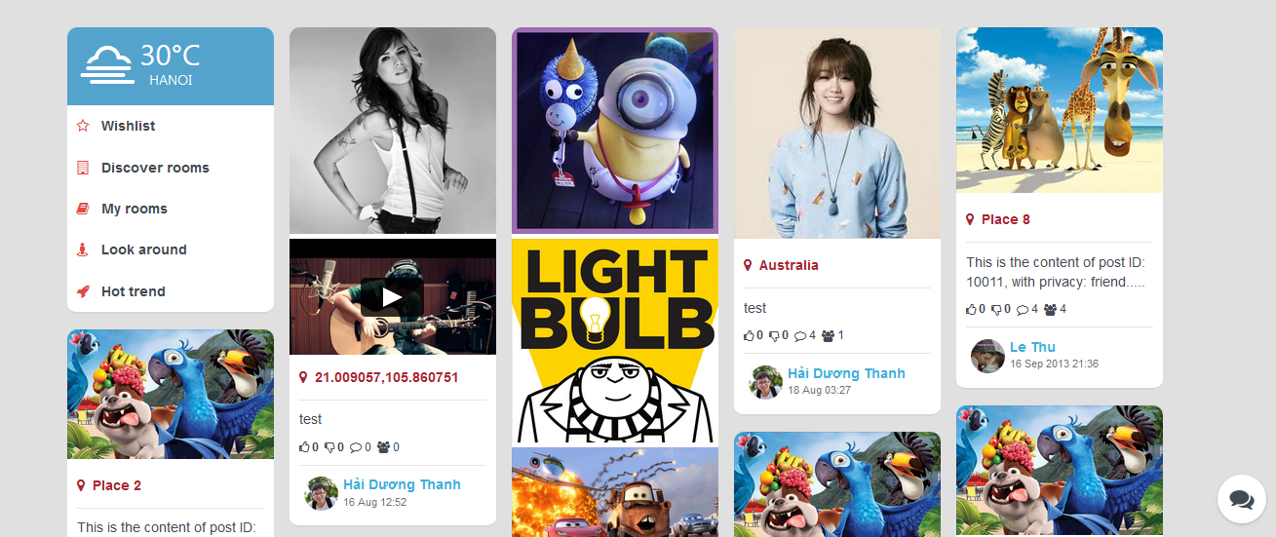

Figure 44: New Feed screen design

|  |  |  |  |  |  |  |  |
| --- | --- | --- | --- | --- | --- | --- | --- |
| No | Field name | Field name in Vietnamese | Type | Require | Mandatory | Max-Length | Description |
|  | Location | Vị trí | Label |  | Y |  | Display information of current location of user |
|  | Wishlist | Danh sách mong muốn | Hyperlink | Click | Y |  | Click to display Wishlist page |
|  | Discover Room | Tìm hiểu phòng | Hyperlink | Click | Y |  | Click to display Room List page |
|  | My Room | Phòng của tôi | Hyperlink | Click | Y |  | Click to display Room List page |
|  | Look Around | Tìm xung quanh | Hyperlink | Click | Y |  | Click to display Look Around page |
|  | Hot Trend | Xu hướng mới | Hyperlink | Click | Y |  | Click to display Hot Trend page |
|  | Post Thumbnail | Hình nhỏ bài đăng | Post | Click | Y |  | Click to display Post Detail page |
|  | Message | Tin nhắn | Button | Click | Y |  | Click to display Chat panel |

Table 15: Display New Feed screen description

#### Display Post Detail

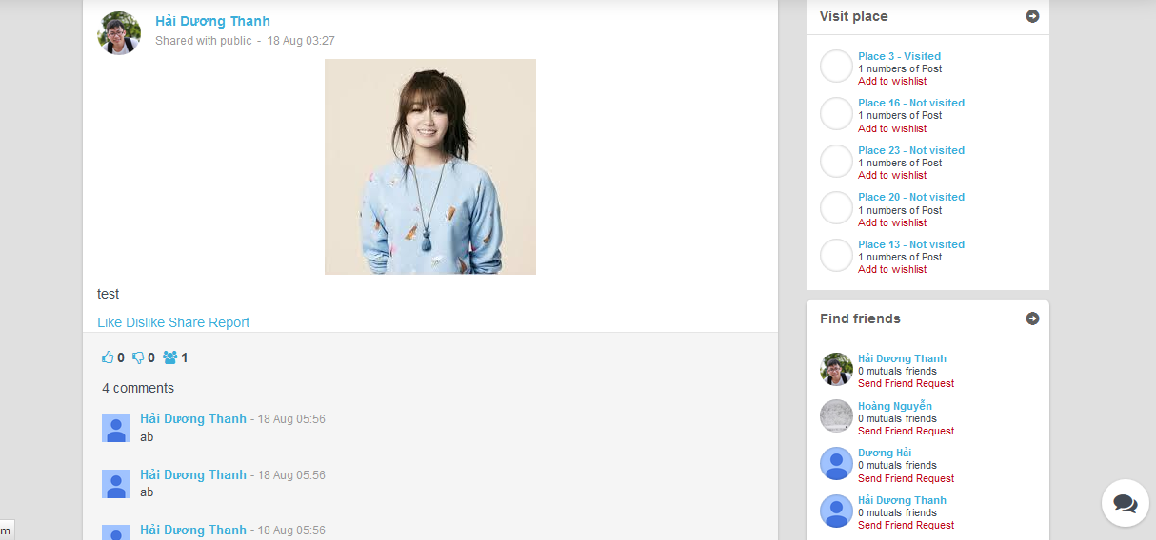

Figure 46: Post Detail screen design

|  |  |  |  |  |  |  |  |
| --- | --- | --- | --- | --- | --- | --- | --- |
| No | Field name | Field name in Vietnamese | Type | Require | Mandatory | Max-Length | Description |
|  | Avatar | Ảnh đại diện | Image | Click | Y |  | Click to display user’s personal page |
|  | User Name | Tên người dung | Hyperlink | Click | Y |  | Click to display user’s personal page |
|  | Information | Thông tin | Label |  | Y |  | Display post’s information |
|  | Image | Hình ảnh | Image |  | Y |  | Display image of post |
|  | Content | Nội dung | Label |  | Y |  | Display content of post |
|  | Like | Thích | Hyperlink | Click | Y |  | Click to mark this post as like |
|  | Dislike | Không thích | Hyperlink | Click | Y |  | Click to mark this post as dislike |
|  | Share | Chia sẻ | Hyperlink | Click | Y |  | Click to share this post |
|  | Report | Báo cáo | Hyperlink | Click | Y |  | Click to report this post |
|  | Rating | Đánh giá | Label |  | Y |  | Display like, dislike, share number of post |
| 1. C | Comment | Bình luận | Comment |  | Y |  | Display comments of post |
|  | Visit Place List | Danh sách địa điểm tham quan | Panel |  | Y |  | Display list of visit place |
|  | Visit Place Item | Địa điểm tham quan | Item | Click | Y |  | Click to display Search Detail page |
|  | Find Friends | Danh sách gợi ý kết bạn | Panel |  | Y |  | Display friend suggestion |
|  | Friend Item | Gợi ý kết bạn | Item | Click | Y |  | Click to send request or display user’s personal page |

Table 16: Post Detail screen description

#### Display Wish List

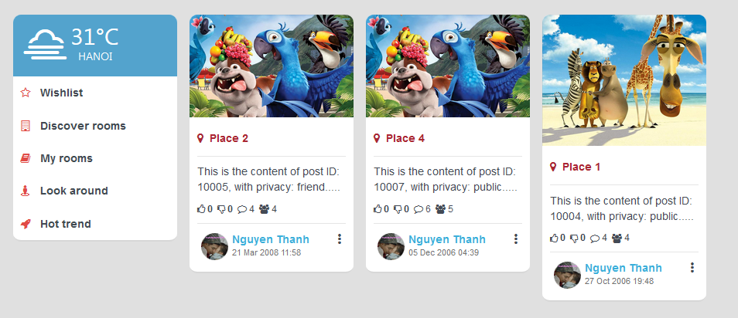

Figure 48: Wish List screen design

|  |  |  |  |  |  |  |  |
| --- | --- | --- | --- | --- | --- | --- | --- |
| No | Field name | Field name in Vietnamese | Type | Require | Mandatory | Max-Length | Description |
|  | Post Thumbnail | Hình nhỏ bài đăng | Post | Click | Y |  | Click to display Post Detail page |

Table 17: Wish List screen description

#### Display Room List

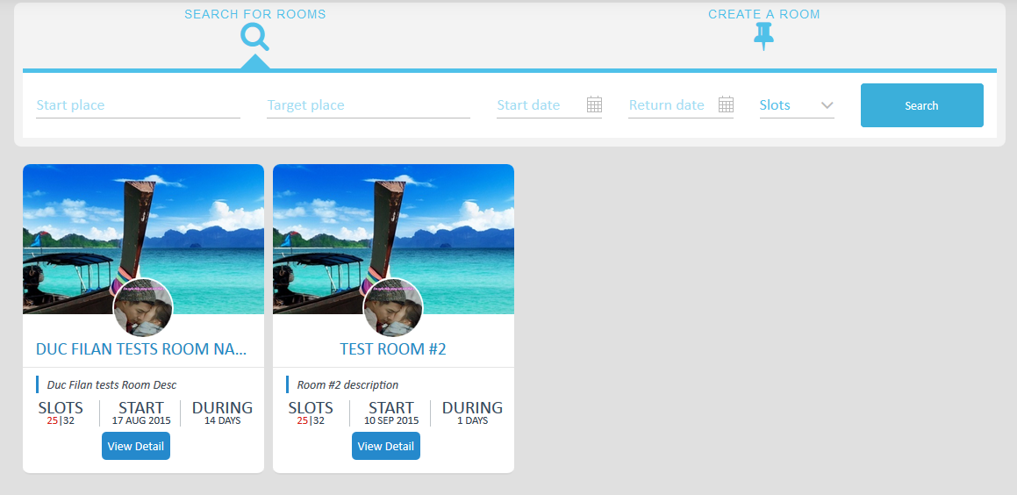

Figure 50: Room List screen design

|  |  |  |  |  |  |  |  |
| --- | --- | --- | --- | --- | --- | --- | --- |
| No | Field name | Field name in Vietnamese | Type | Require | Mandatory | Max-Length | Description |
|  | Room Thumbnail | Hình nhỏ phòng | Room | Click | Y |  | Click to display Room Detail page |

#### Display Room Detail

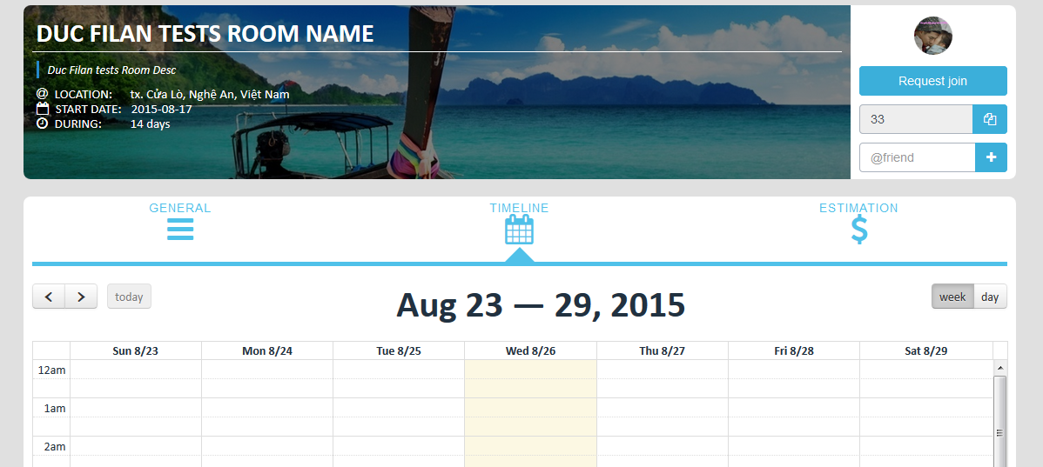

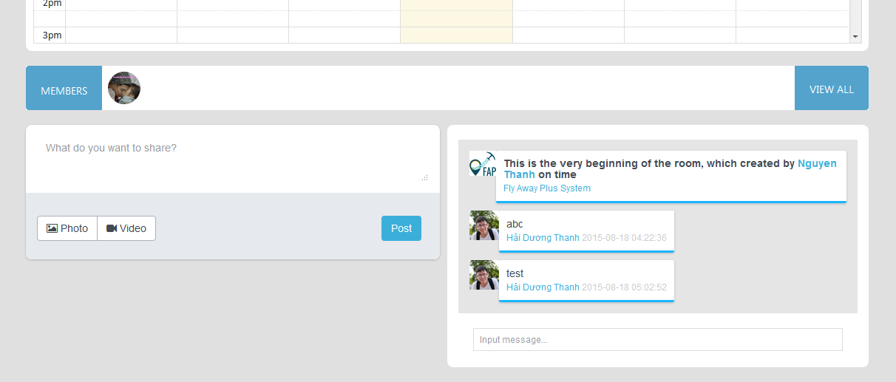

Figure 52: Room Detail screen design

|  |  |  |  |  |  |  |  |
| --- | --- | --- | --- | --- | --- | --- | --- |
| No | Field name | Field name in Vietnamese | Type | Require | Mandatory | Max-Length | Description |
|  | Room Information | Thông tin phòng | Panel |  | Y |  | Display information of room |
|  | Interaction | Tương tác | Panel | Click  Type | Y |  | Interaction of room |
|  | Estimation | Dự toán | Panel | Click  Type | Y |  | Plan, estimation of room |
|  | Member | Thành viên | Image | Click | Y |  | Click to display User’s Personal page |
|  | View All | Xem tất cả | Button | Click | Y |  | Click to display member list |
|  | Create Post | Tạo bài đăng | Panel | Click  Type | Y |  | Input data and click Post to create a post |
|  | Chat Box | Khung tán gẫu | Chat box |  | Y |  | Display messages |
|  | Message | Tin nhắn | Panel |  | Y |  | Display message history |
|  | Chat | Tán gẫu | Text box | Type | Y |  | Send message |

Table 18: Room Detail screen description

#### Display Photo List

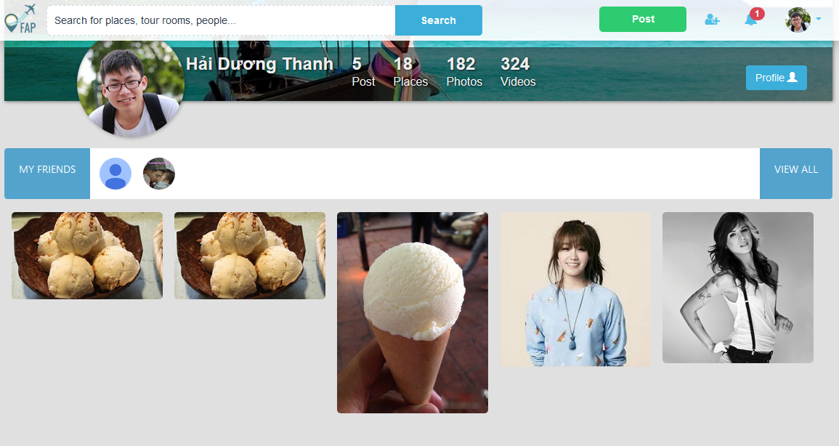

Figure 54: Display Photo List screen design

|  |  |  |  |  |  |  |  |
| --- | --- | --- | --- | --- | --- | --- | --- |
| No | Field name | Field name in Vietnamese | Type | Require | Mand-atory | Max-Length | Description |
| 1 | Avatar | Ảnh đại diện | Image | Image | Y |  | Avatar of user |
| 2 | Username | Tên người dùng | Text | Text | Y |  | Username |
| 3 | Post | Bài đăng | Tab | Tab | Y |  | List Post of User |
| 4 | Places | Địa điểm | Tab | Tab | Y |  | List Place of User |
| 5 | Photos | Ảnh | Tab | Tab | Y |  | List Photo of User |
| 6 | Profile | Tiểu sử | Button | Click | Y |  | Show profile of User |
| 7 | FriendList | Danh sách bạn | List | List | Y |  | List friend of User |
| 8 | ViewAll | Xem tất cả | Button | Click | Y |  | View all User |
| 9 | ListPhoto | Danh sách ảnh | List | List | Y |  | List Photo of User |

#### Display Video List

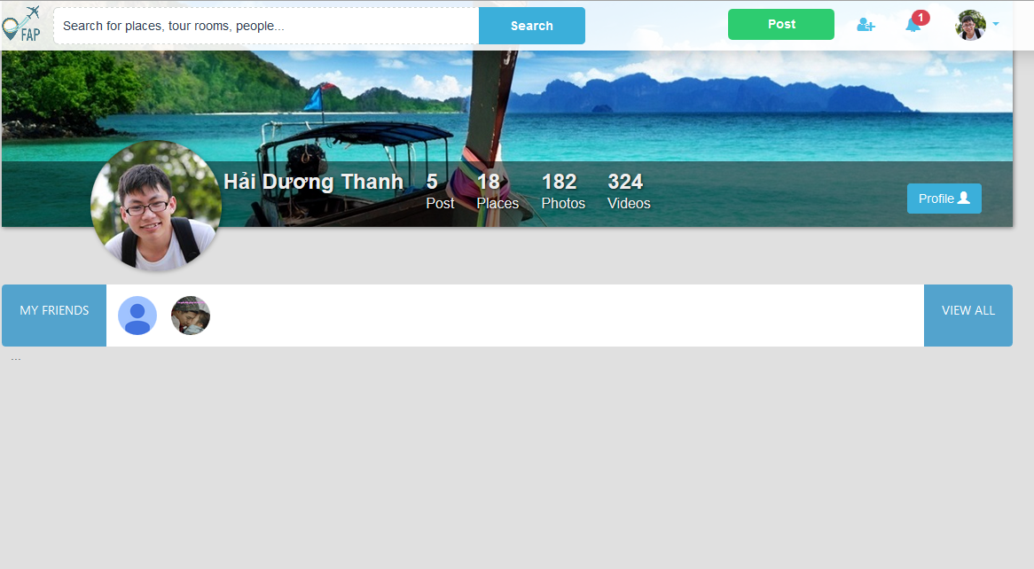

Figure 56: Display Video List screen design

|  |  |  |  |  |  |  |  |
| --- | --- | --- | --- | --- | --- | --- | --- |
| No | Field name | Field name in Vietnamese | Type | Require | Mand-atory | Max-Length | Description |
| 1 | Avatar | Ảnh đại diện | Image | Image | Y |  | Avatar of user |
| 2 | Username | Tên người dùng | Text | Text | Y |  | Username |
| 3 | Post | Bài đăng | Tab | Tab | Y |  | List Post of User |
| 4 | Places | Địa điểm | Tab | Tab | Y |  | List Place of User |
| 5 | Photos | Ảnh | Tab | Tab | Y |  | List Photo of User |
| 6 | Profile | Tiểu sử | Button | Click | Y |  | Show profile of User |
| 7 | FriendList | Danh sách bạn | List | List | Y |  | List friend of User |
| 8 | ViewAll | Xem tất cả | Button | Click | Y |  | View all User |
| 9 | ListVideo | Danh sách video | List | List | Y |  | List Video of User |

#### Display Place List

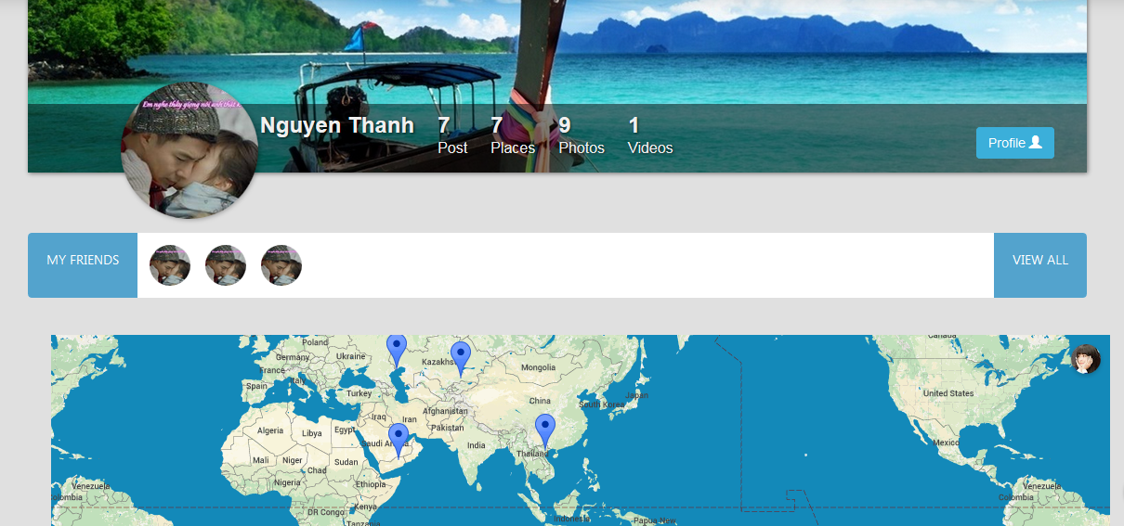

Figure 58: Display Place List screen design

|  |  |  |  |  |  |  |  |
| --- | --- | --- | --- | --- | --- | --- | --- |
| No | Field name | Field name in Vietnamese | Type | Require | Mand-atory | Max-Length | Description |
| 1 | Map | Bản đồ | Map | Click | Y |  | Display visited places in a map |

Table 19: Display Place List screen description

#### View Place

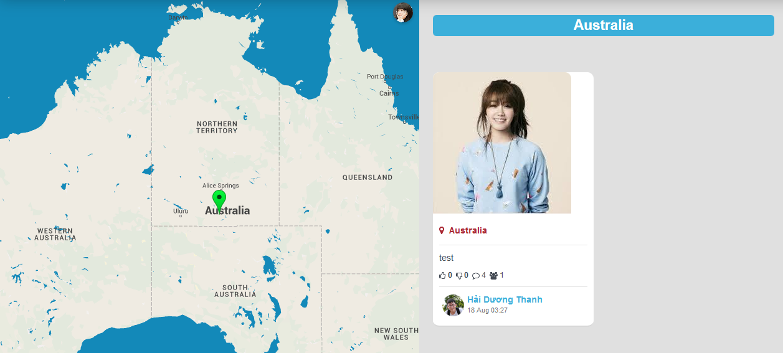

Figure 60: View Place screen design

|  |  |  |  |  |  |  |  |
| --- | --- | --- | --- | --- | --- | --- | --- |
| No | Field name | Field name in Vietnamese | Type | Require | Mand-atory | Max-Length | Description |
| 1 | Map | Bản đồ | Map | Click | Y |  | Display visited places in a map |
| 2 | Place Name | Tên địa điểm | Label |  | Y |  | Display name of place |
| 3 | Post Thumbnail | Hình nhỏ bài đăng | Post | Click | Y |  | Click to display Post Detail page |

Table 20: View Place screen description

#### Post Management

#### Create Post

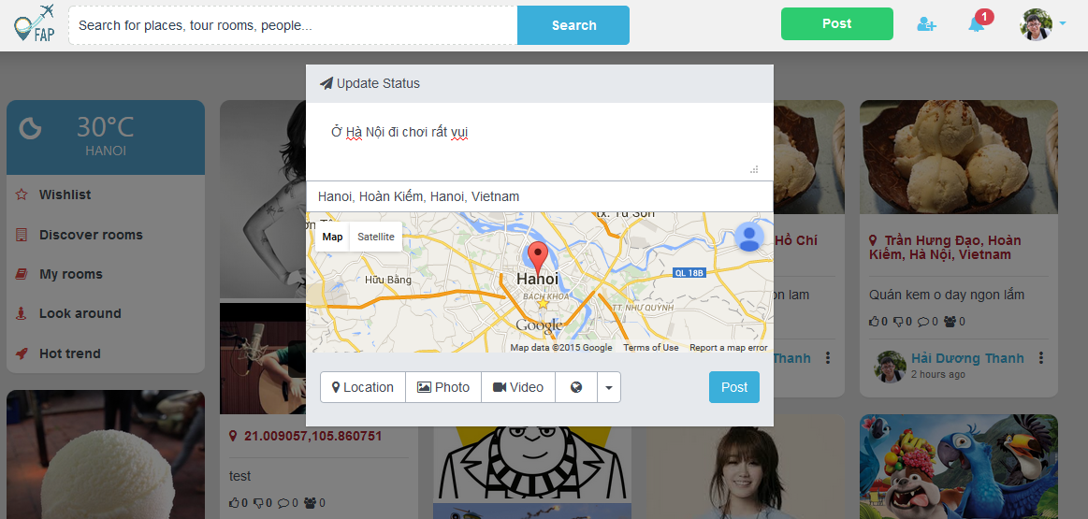

Figure 63: Create Post screen design

|  |  |  |  |  |  |  |  |
| --- | --- | --- | --- | --- | --- | --- | --- |
| No | Field name | Field name in Vietnamese | Type | Require | Mand-atory | Max-Length | Description |
| 1 | UpdateStatusLabel | Cập nhật trạng thái | Label | Label | Y |  | Label display “Update Status” |
| 2 | PostContent | Nội dung bài đăng | Text | Text | Y |  | Post’s content |
| 3 | InputTextPlace | Nhập địa điểm | Input text | Input text | Y |  | Input text place |
| 4 | Map | Bản đồ | Google map | Google map | Y |  | Google map show place |
| 5 | Location | Địa điểm | Button | CLick | Y |  | Show location |
| 6 | Photo | Ảnh | Button | Click | Y |  | Show Photo tab to post photo |
| 7 | Video | Video | Button | Click | Y |  | Show Video tab to post video |
| 8 | Post | Bài đăng | Button | Click | Y |  | Button for post |

#### Edit Post

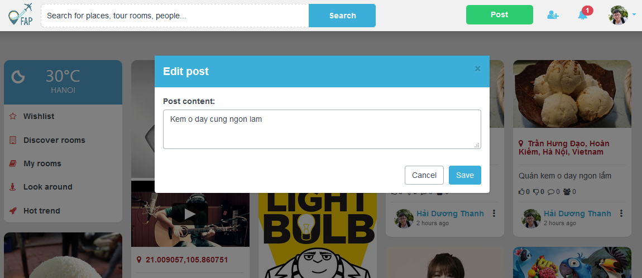

Figure 65: Edit Post screen design

|  |  |  |  |  |  |  |  |
| --- | --- | --- | --- | --- | --- | --- | --- |
| No | Field name | Field name in Vietnamese | Type | Require | Mand-atory | Max-Length | Description |
| 1 | editPostLabel | Chỉnh sửa bài đăng | Label | Label | Y |  | Label display “Edit post” |
| 2 | PostContent | Nội dung bài đăng | Text | Text | Y |  | Post’s content |
| 3 | Cancel | Hủy bỏ | Button | Button | Y |  | Cancel edit post |
| 4 | Save | Lưu | Button | Button | Y |  | Save post’s content |

#### Delete Post

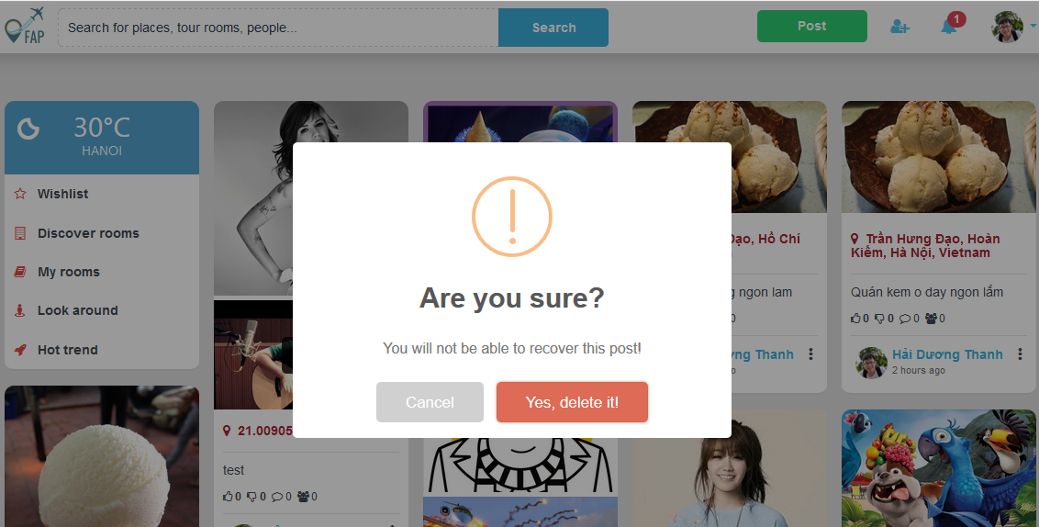

Figure 67: Delete Post screen design

|  |  |  |  |  |  |  |  |
| --- | --- | --- | --- | --- | --- | --- | --- |
| No | Field name | Field name in Vietnamese | Type | Require | Mand-atory | Max-Length | Description |
| 1 | ConfirmLabel | Bạn có chắc có | Label | Label | Y |  | Label display “Are you sure?” |
| 2 | Cancel | Hủy bỏ | Button | Button | Y |  | Cancel delete post |
| 3 | Confirm | Có | Button | Button | Y |  | Delete post |

#### Share Post

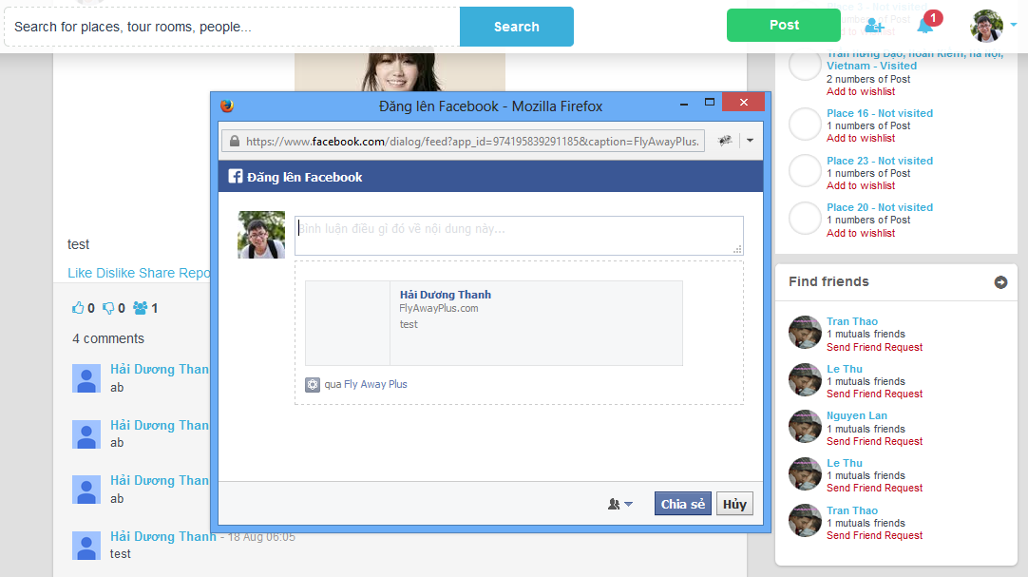

Figure 69: Share Post screen design

|  |  |  |  |  |  |  |  |
| --- | --- | --- | --- | --- | --- | --- | --- |
| No | Field name | Field name in Vietnamese | Type | Require | Mand-atory | Max-Length | Description |
| 1 | Facebook | Facebook | Icon | Icon | Y |  | Facebook |
| 2 | Avatar | Ảnh đại diện | Image | Image | Y |  | Avatar of User |
| 3 | PostContent | Nội dung bài đăng | Text | Text | Y |  | Post’s content |
| 4 | Privacy | Quyền riêng tư | Button | Click | Y |  | Privacy of Post |
| 5 | Share | Chia sẻ | Button | Click | Y |  | Share button to Facebook |
| 6 | Cancel | Hủy | Button | Click | Y |  | Cancel Share post |

#### Comment Management

#### Add Comment

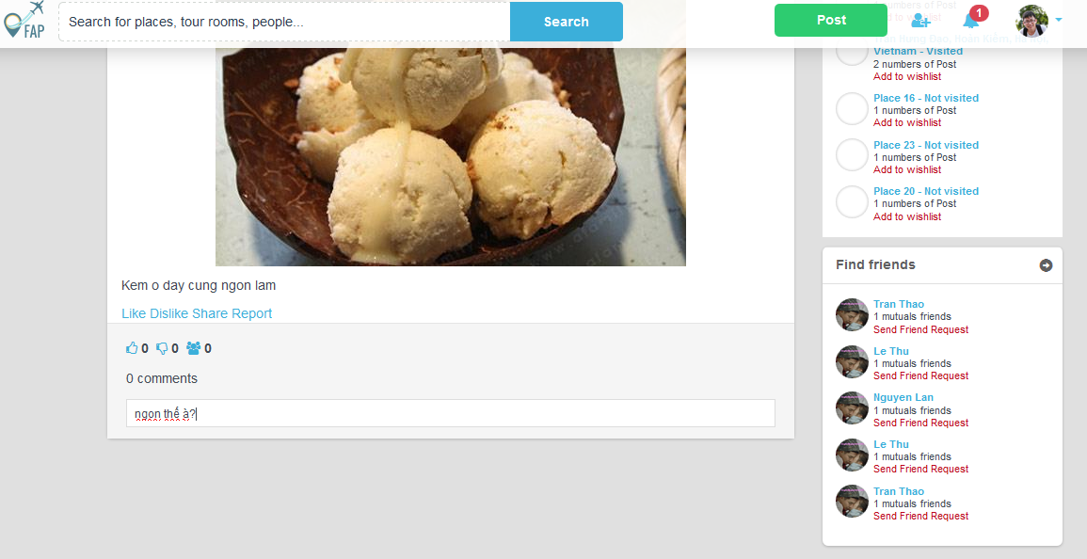

Figure 72: Add Comment screen diagram

|  |  |  |  |  |  |  |  |
| --- | --- | --- | --- | --- | --- | --- | --- |
| No | Field name | Field name in Vietnamese | Type | Require | Mand-atory | Max-Length | Description |
| 1 | Post content | Nội dung bài đăng | Text | Text | Y |  | Post’s content |
| 2 | Like | Thích | Button | Click | Y |  | Like Post |
| 3 | Dislike | Không thích | Button | Click | Y |  | Dislike Post |
| 4 | Share | Chia sẻ | Button | Click | Y |  | Share button to Facebook |
| 5 | Report | Báo cáo | Button | Click | Y |  | Report post to system |
| 6 | CommentText | Bình luận | Text | Text | Y |  | Comment |

#### Edit Comment

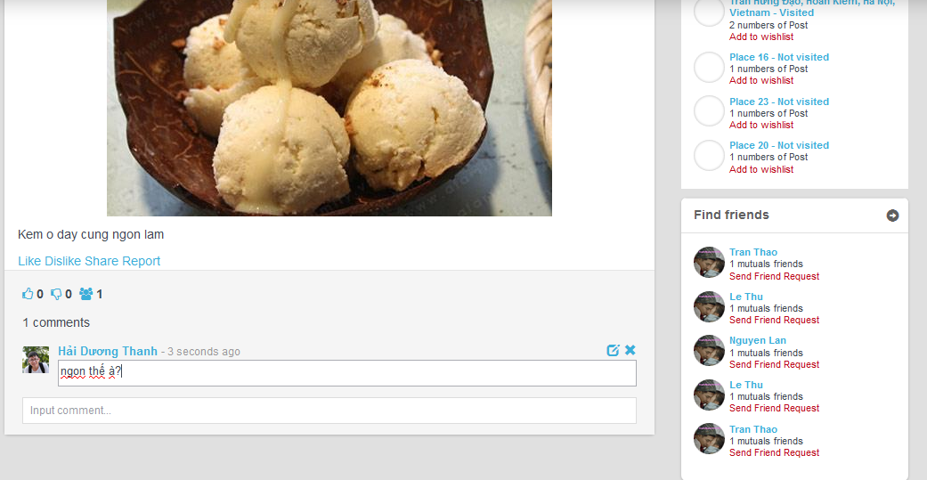

Figure 74: Edit Comment screen design

|  |  |  |  |  |  |  |  |
| --- | --- | --- | --- | --- | --- | --- | --- |
| No | Field name | Field name in Vietnamese | Type | Require | Mand-atory | Max-Length | Description |
| 1 | Post content | Nội dung bài đăng | Text | Text | Y |  | Post’s content |
| 2 | Like | Thích | Button | Click | Y |  | Like Post |
| 3 | Dislike | Không thích | Button | Click | Y |  | Dislike Post |
| 4 | Share | Chia sẻ | Button | Click | Y |  | Share button to Facebook |
| 5 | Report | Báo cáo | Button | Click | Y |  | Report post to system |
| 6 | EditComment | Chỉnh sửa bình luận | Button | Click | Y |  | Edit Comment |
| 7 | DeleteComment | Xóa bình luận | Button | Click | Y |  | Delete Comment |
| 8 | CommentText | Bình luận | Text | Text | Y |  | Comment |

#### Delete Comment



Figure 76: Delete screen design

|  |  |  |  |  |  |  |  |
| --- | --- | --- | --- | --- | --- | --- | --- |
| No | Field name | Field name in Vietnamese | Type | Require | Mand-atory | Max-Length | Description |
| 1 | Post content | Nội dung bài đăng | Text | Text | Y |  | Post’s content |
| 2 | Like | Thích | Button | Click | Y |  | Like Post |
| 3 | Dislike | Không thích | Button | Click | Y |  | Dislike Post |
| 4 | Share | Chia sẻ | Button | Click | Y |  | Share button to Facebook |
| 5 | Report | Báo cáo | Button | Click | Y |  | Report post to system |
| 6 | EditComment | Chỉnh sửa bình luận | Button | Click | Y |  | Edit Comment |
| 7 | DeleteComment | Xóa bình luận | Button | Click | Y |  | Delete Comment |
| 8 | CommentText | Bình luận | Text | Text | Y |  | Comment |

#### Like Management

#### Like

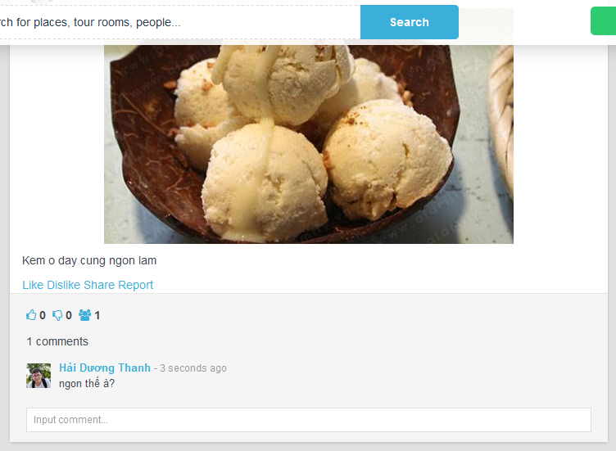

Figure 79: Like screen design

|  |  |  |  |  |  |  |  |
| --- | --- | --- | --- | --- | --- | --- | --- |
| No | Field name | Field name in Vietnamese | Type | Require | Mand-atory | Max-Length | Description |
| 1 | Post content | Nội dung bài đăng | Text | Text | Y |  | Post’s content |
| 2 | Like | Thích | Button | Click | Y |  | Like Post |
| 3 | Dislike | Không thích | Button | Click | Y |  | Dislike Post |
| 4 | Share | Chia sẻ | Button | Click | Y |  | Share button to Facebook |
| 5 | Report | Báo cáo | Button | Click | Y |  | Report post to system |
| 6 | EditComment | Chỉnh sửa bình luận | Button | Click | Y |  | Edit Comment |
| 7 | DeleteComment | Xóa bình luận | Button | Click | Y |  | Delete Comment |
| 8 | CommentText | Bình luận | Text | Text | Y |  | Comment |

#### Dislike



Figure 81: Dislike screen design

|  |  |  |  |  |  |  |  |
| --- | --- | --- | --- | --- | --- | --- | --- |
| No | Field name | Field name in Vietnamese | Type | Require | Mand-atory | Max-Length | Description |
| 1 | Post content | Nội dung bài đăng | Text | Text | Y |  | Post’s content |
| 2 | Like | Thích | Button | Click | Y |  | Like Post |
| 3 | Dislike | Không thích | Button | Click | Y |  | Dislike Post |
| 4 | Share | Chia sẻ | Button | Click | Y |  | Share button to Facebook |
| 5 | Report | Báo cáo | Button | Click | Y |  | Report post to system |
| 6 | EditComment | Chỉnh sửa bình luận | Button | Click | Y |  | Edit Comment |
| 7 | DeleteComment | Xóa bình luận | Button | Click | Y |  | Delete Comment |
| 8 | CommentText | Bình luận | Text | Text | Y |  | Comment |

Figure 82: Dislike sequence diagram

#### Report

#### Report a post

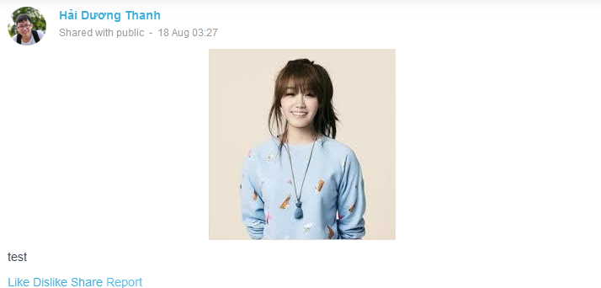

Figure 85: Report Post screen design

|  |  |  |  |  |  |  |  |
| --- | --- | --- | --- | --- | --- | --- | --- |
| No | Field name | Field name in Vietnamese | Type | Require | Mandatory | Max-Length | Description |
|  | Report Post | Báo cáo bài viết | Button | Click | Y |  | Click to report post |

Table 21: Report Post screen description

#### Report an user

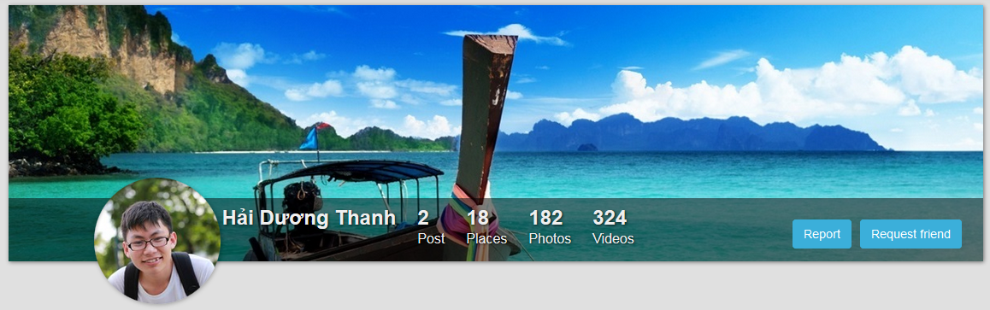

Figure 87: Report User screen design

|  |  |  |  |  |  |  |  |
| --- | --- | --- | --- | --- | --- | --- | --- |
| No | Field name | Field name in Vietnamese | Type | Require | Mandatory | Max-Length | Description |
|  | Report User | Báo cáo người dung | Button | Click | Y |  | Click to report user |

Table 22: Report User screen description

#### Chat

|  |  |
| --- | --- |
|  | C:\Users\Nguyen Minh Hoang\Desktop\Chat.PNG |
| Figure 90: Chat screen 1 | Figure 54: Chat screen 2 |

|  |  |  |  |  |  |  |  |
| --- | --- | --- | --- | --- | --- | --- | --- |
| No | Field name | Field name in Vietnamese | Type | Require | Mandatory | Max-Length | Description |
|  | Chat | Nút chat | Button | Click | Y |  | Chat button |
|  | Message List Box | Khung chat | List Chat Item |  | Y |  | Display friend list |
|  | Friend Chat Item | Bạn | Chat Item | Click |  |  | Friend item to chat |
|  | Friend Avatar | Ảnh đại diện của bạn | Image | Click | Y |  | User’s avatar |
|  | Friend Name | Tên bạn | Hyperlink | Click | Y |  | Friend’s name |
|  | Message Content | Nội dung tin nhắn | Label |  | Y |  | Latest message |
|  | Time | Thời gian nhận tin nhắn | Label |  | Y |  | Message received time |
|  | Friend Chat |  | Button | Click | Y |  |  |
|  | Chat Box |  | Chat Box |  | Y |  | Display message |
|  | Friend Name |  | Hyperlink | Click | Y |  | Display friend’s name |
|  | Message Display Box |  | Conversation Box |  | Y |  | Display messages |
|  | Message |  | Textbox | Type | Y |  | User enters message into |

#### Friend Management

#### Add Friend

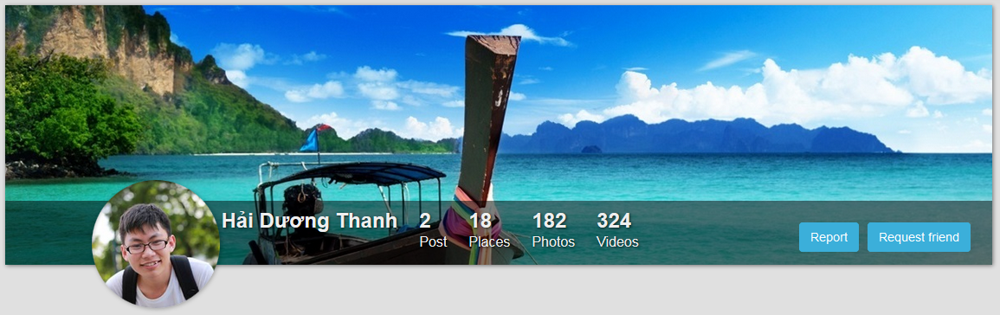

Figure 93: Request friend screen

|  |  |  |  |  |  |  |  |
| --- | --- | --- | --- | --- | --- | --- | --- |
| No | Field name | Field name in Vietnamese | Type | Require | Mandatory | Max-Length | Description |
|  | Request Friend | Yêu cầu kết bạn | Button |  | Y |  | Send a making friend request |

Table 23: Request friend screen description

#### Unfriend

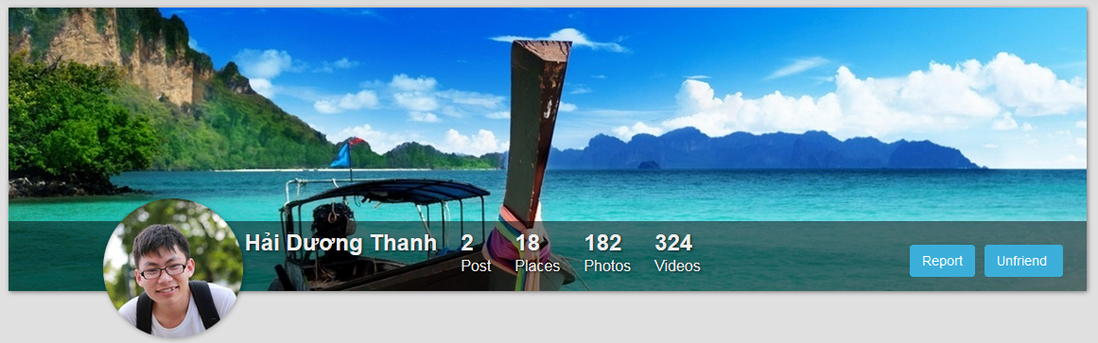

Figure 95: Unfriend screen

|  |  |  |  |  |  |  |  |
| --- | --- | --- | --- | --- | --- | --- | --- |
| No | Field name | Field name in Vietnamese | Type | Require | Mandatory | Max-Length | Description |
|  | Unfriend | Hủy kết bạn | Button |  | Y |  | Remove an user from friend list |

Table 24: Unfriend screen description

#### Wish List

#### Add to Wish List

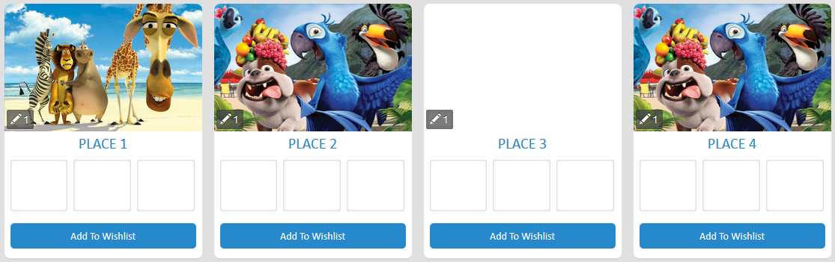

Figure 98: Add to Wish list screen

|  |  |  |  |  |  |  |  |
| --- | --- | --- | --- | --- | --- | --- | --- |
| No | Field name | Field name in Vietnamese | Type | Require | Mandatory | Max-Length | Description |
|  | Add To Wish List | Thêm vào danh sách mong muốn | Button | Click | Y |  | Add a place into wish list |

Table 25: Add to wish list screen description

#### Remove From Wish List

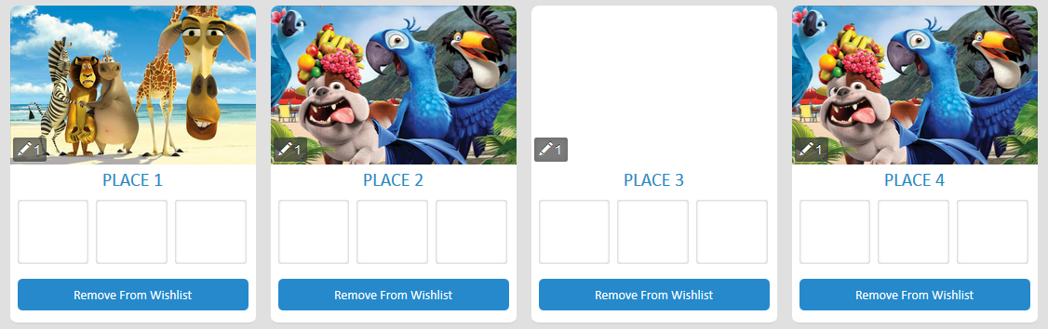

Figure 100: Remove from Wish list screen

|  |  |  |  |  |  |  |  |
| --- | --- | --- | --- | --- | --- | --- | --- |
| No | Field name | Field name in Vietnamese | Type | Require | Mandatory | Max-Length | Description |
| 1 | Remove From Wish List | Xóa khỏi danh sách mong muốn | Button | Click | Y |  | Remove a place from wish list |

Table 26: Remove from Wish list screen description

#### Room

#### Create Room

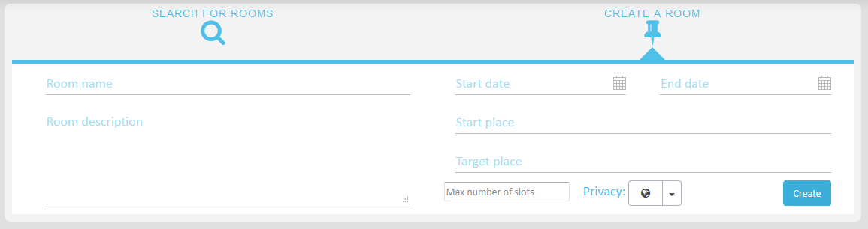

Figure 103: Create Room screen

|  |  |  |  |  |  |  |  |
| --- | --- | --- | --- | --- | --- | --- | --- |
| No | Field name | Field name in Vietnamese | Type | Require | Mandatory | Max-Length | Description |
| 1 | Room name | Tên phòng | Text box | Type | Y |  | User type room’s name |
| 2 | No. of slots | Số lượng thành viên | Number | Type | Y |  | User type maxium number of members that can join room |
| 3 | Start place | Điểm khởi hành | Text box | Type | Y |  | User chosse start place |
| 4 | Target place | Điểm đến | Text box | Type | Y |  | User chosse target place |
| 5 | Start date | Ngày khởi hành | Calendar | Type | Y |  | User choose start date |
| 6 | End date | Ngày kết thúc | Calendar | Type | Y |  | User choose end date |
| 7 | Public switch | Chọn chế độ public/private room | Switch | Click | Y |  | User chosse public or private room |
| 8 | Room description | Giới thiệu về phòng | Text area | Type | Y |  | User write room description |
| 9 | Create | Tạo phòng | Button | Click | Y |  | User click to create room |

#### Add General Plan

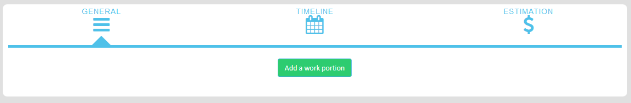

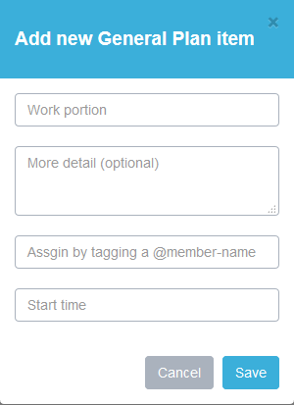

Figure 105: Add general plan screen design

|  |  |  |  |  |  |  |  |
| --- | --- | --- | --- | --- | --- | --- | --- |
| No | Field name | Field name in Vietnamese | Type | Require | Mandatory | Max-Length | Description |
|  | Add Plan | Thêm kế hoạch | Text box | Click | Y |  | Plan of the room |
|  | Add New Plan | Thêm kế hoạch mới | Panel |  | Y |  | Add plan form |
|  | Work Portion | Phần công việc | Text box | Type | Y |  | Work portion of plan |
|  | Detail | Mô tả công việc | Text box | Type | Y |  | Description of work portion |
|  | Assignee | Người thực hiện | Text box | Type | Y |  | Assignee of plan |
|  | Start Time | Ngày bắt đầu | Text box | Type | Y |  | Start time of plan |
|  | Cancel | Hủy bỏ | Button | Click | Y |  | Cancel creating plan |
|  | Save | Tạo kế hoạch | Button | Click | Y |  | Create a plan |

#### Add Timeline Plan

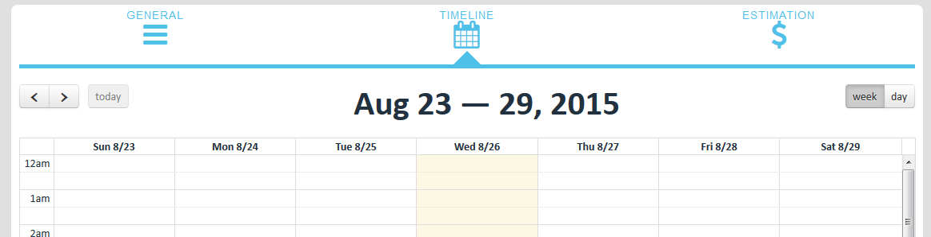

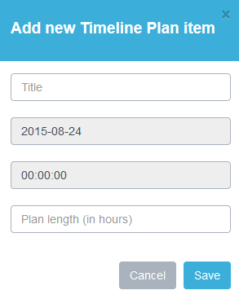

Figure 107: Add Timeline Plan

|  |  |  |  |  |  |  |  |
| --- | --- | --- | --- | --- | --- | --- | --- |
| No | Field name | Field name in Vietnamese | Type | Require | Mandatory | Max-Length | Description |
|  | Plan Time | Ngày dự kiến | Label |  | Y |  | Plan time of room |
|  | Previous Week | Tuần trước | Button | Click | Y |  | Jump to previous week |
|  | Next Week | Tuần sau | Button | Click | Y |  | Jump to next week |
|  | Week | Tuần | Button | Click | Y |  | Display plan calendar by week |
|  | Day | Ngày | Button | Click | Y |  | Display plan calendar by day |
|  | Plan Calendar | Lịch kế hoạch | Calendar |  | Y |  | Calendar of plan |
|  | Plan Calendar Item | Đơn vị lịch kế hoạch | Calendar Item | Click | Y |  | Plan detail by day |
|  | Timeline Plan | Kế hoạch theo ngày | Panel |  | Y |  | Create timeline plan form |
|  | Title | Tiêu đề | Text box | Type | Y |  | Titile of timeline plan |
|  | Timeline Plan Date | Ngày theo kế hoạch | Text box |  |  |  | Date of plan |
|  | Time Plan Time | Giờ theo kế hoạch | Text box |  |  |  | Time of plan |
|  | Plan Length | Độ dài kế hoạch | Text box | Type | Y |  | Length of plan |
|  | Cancel | Hủy bỏ | Button | Click | Y |  | Cancel creating plan |
|  | Save | Tạo kế hoạch | Button | Click | Y |  | Create a plan |

Table 27: Add Timeline Plan screen description

#### Account Management

#### Login

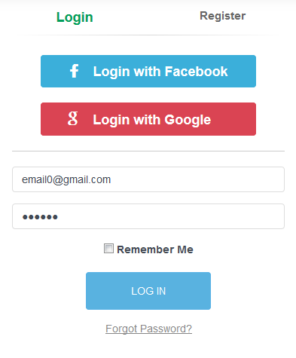

Figure 110: Login screen design

|  |  |  |  |  |  |  |  |
| --- | --- | --- | --- | --- | --- | --- | --- |
| No | Field name | Field name in Vietnamese | Type | Require | Mandatory | Max-Length | Description |
|  | Login with Facebook | Đăng nhập qua Facebook | Button | Click | Y |  | Login with Facebook |
|  | Login with Google | Đăng nhập qua Google | Button | Click | Y |  | Login with Google+ |
|  | Email | Thư điện tử | Text box | Type | Y |  | Email of registered user |
|  | Password | Mật khẩu | Text box | Type | Y |  | Password of registered user |
|  | Day | Ngày | Button | Click | Y |  | Display plan calendar by day |
|  | Remember Me | Lưu thông tin đăng nhập | Check box | Click | Y |  | Save login information |
|  | Login | Đăng nhập | Button | Click | Y |  | Login |
|  | Forgot Password | Quên mật khẩu | Hyperlink | Click | Y |  | Resend password to user |

Table 28: Login screen description

#### Logout

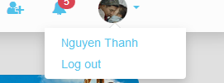

Figure 112: Logout screen design

|  |  |  |  |  |  |  |  |
| --- | --- | --- | --- | --- | --- | --- | --- |
| No | Field name | Field name in Vietnamese | Type | Require | Mandatory | Max-Length | Description |
|  | Logout | Đăng xuất | Hyperlink | Click | Y |  | Logout |

Table 29: Logout screen description

#### Register

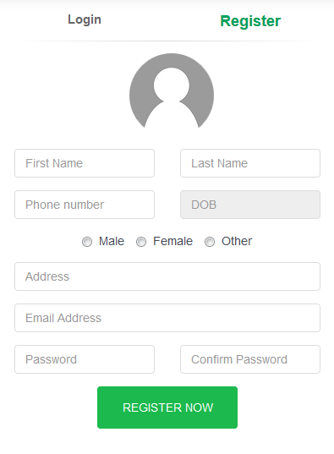

Figure 114: Register screen design

|  |  |  |  |  |  |  |  |
| --- | --- | --- | --- | --- | --- | --- | --- |
| No | Field name | Field name in Vietnamese | Type | Require | Mandatory | Max-Length | Description |
|  | Register | Đăng ký | Hyperlink | Click | Y |  | Display register form |
|  | Avatar | Ảnh đại diện | Button | Click | Y |  | Display file chooser to upload avatar |
|  | First Name | Tên | Text box | Type | Y |  | First name of user |
|  | Last Name | Họ | Text box | Type | Y |  | Last name of user |
|  | Phone Number | Số điện thoại | Text box | Type | Y |  | Phone number of user |
|  | DOB | Ngày tháng năm sinh | Date picker | Click | Y |  | Date of birth of user |
|  | Gender | Giới tính | Radio button group | Click | Y |  | Gender of user |
|  | Address | Địa chỉ | Text box | Type | Y |  | Address of user |
|  | Password | Mật khẩu | Text box | Type | Y |  | Password of user |
|  | Confirm Password | Nhập lại mật khẩu | Text box | Type | Y |  | User retype password |
|  | Register | Đăng ký | Button | Type | Y |  | User register a new account |

Table 30: Register screen description

#### Edit Profile

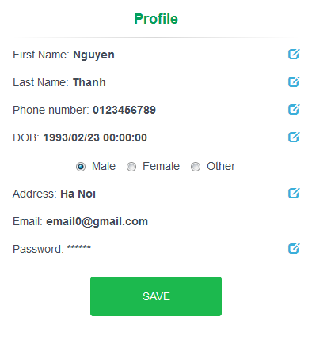

Figure 116: Edit Profile screen design

|  |  |  |  |  |  |  |  |
| --- | --- | --- | --- | --- | --- | --- | --- |
| No | Field name | Field name in Vietnamese | Type | Require | Mandatory | Max-Length | Description |
|  | Profile | Thông tin cá nhân | Label |  | Y |  | Display panel name |
|  | First Name | Tên | Label |  | Y |  | First name of user |
|  | First Name Edit | Sửa tên | Button | Click | Y |  | Edit first name of user |
|  | Last Name | Họ | Label |  | Y |  | Last name of user |
|  | Last Name Edit | Sửa họ | Button | Click | Y |  | Edit last name of user |
|  | Phone Number | Số điện thoại | Label |  | Y |  | Phone number of user |
|  | Phone Number Edit | Sửa số điện thoại | Button | Click | Y |  | Edit phone number of user |
|  | DOB | Ngày tháng năm sinh | Label |  | Y |  | Date of birth of user |
|  | DOB Edit | Sửa ngày tháng năm sinh | Button | Click | Y |  | Edit date of birth of user |
|  | Gender | Giới tính | Radio button group | Click | Y |  | Gender of user |
|  | Address | Địa chỉ | Label |  | Y |  | Address of user |
|  | Address Edit | Sửa địa chỉ | Button | Click | Y |  | Edit address of user |
|  | Email | Thư điện tử | Label |  | Y |  | Email of user |
|  | Password | Mật khẩu | Label |  | Y |  | Password of user |
|  | Password Edit | Đổi mật khẩu | Button | Click | Y |  | Edit password of user |
|  | Save | Lưu thông tin | Button | Click | Y |  | Save new information of user |

Table 31: Edit Profile screen description

#### Forgot Password

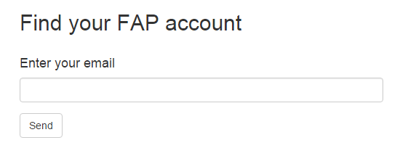

Figure 118: Forgot Password screen design

|  |  |  |  |  |  |  |  |
| --- | --- | --- | --- | --- | --- | --- | --- |
| No | Field name | Field name in Vietnamese | Type | Require | Mandatory | Max-Length | Description |
| 1 | Email | Thư điện tử | Text | Text | Y | 100 | User input email with length less than 100 characters |
| 2 | Find | Tìm password | Button | Click | Y |  | Click to receive password via email |

Table 32: Forgot Password screen description

#### Management Member’s Account

#### Admin Login

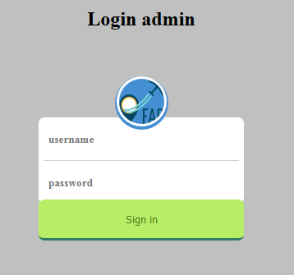

Figure 121: Admin Login screen design

|  |  |  |  |  |  |  |  |
| --- | --- | --- | --- | --- | --- | --- | --- |
| No | Field name | Field name in Vietnamese | Type | Require | Mandatory | Max-Length | Description |
|  | Admin Username | Tên đăng nhập của quản lý | Text box | Type | Y |  | Username of admin |
|  | Admin Password | Mật khẩu của quản lý | Text box | Type | Y |  | Password of admin |
|  | Login | Đăng nhập | Button | Click | Y |  | Click to login |

Table 33: Admin Login screen description

#### Admin Logout

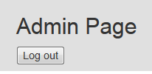

Figure 123: Admin Logout screen design

|  |  |  |  |  |  |  |  |
| --- | --- | --- | --- | --- | --- | --- | --- |
| No | Field name | Field name in Vietnamese | Type | Require | Mandatory | Max-Length | Description |
| 1 | Logout | Đăng xuất | Button | Click | Y |  | Click to logout |

#### Lock User

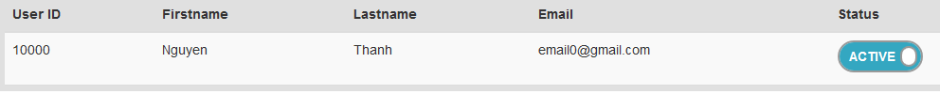

Figure 125: Lock User screen design

|  |  |  |  |  |  |  |  |
| --- | --- | --- | --- | --- | --- | --- | --- |
| No | Field name | Field name in Vietnamese | Type | Require | Mandatory | Max-Length | Description |
| 1 | Lock User | Khóa người dung | Toggle button | Click | Y |  | Click to lock user |

#### Unlock User

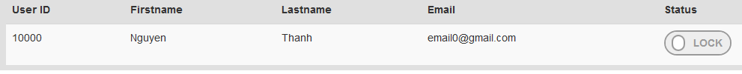

Figure 127: Unlock User screen design

|  |  |  |  |  |  |  |  |
| --- | --- | --- | --- | --- | --- | --- | --- |
| No | Field name | Field name in Vietnamese | Type | Require | Mandatory | Max-Length | Description |
| 1 | Unlock User | Mở khóa người dung | Toggle button | Click | Y |  | Click to unlock user |

#### Review Post

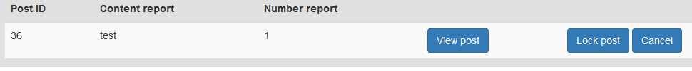

Figure 129: Review Post screen design

|  |  |  |  |  |  |  |  |
| --- | --- | --- | --- | --- | --- | --- | --- |
| No | Field name | Field name in Vietnamese | Type | Require | Mandatory | Max-Length | Description |
| 1 | View Post | Xem bài viết | Button | Click | Y |  | Click to redirect to post |

#### Lock Post



Figure 131: Lock Post screen design

|  |  |  |  |  |  |  |  |
| --- | --- | --- | --- | --- | --- | --- | --- |
| No | Field name | Field name in Vietnamese | Type | Require | Mandatory | Max-Length | Description |
| 1 | Lock Post | Khóa bài viết | Button | Click | Y |  | Click to lock post |